**Performance testing Reports**

**Aggregate Report**

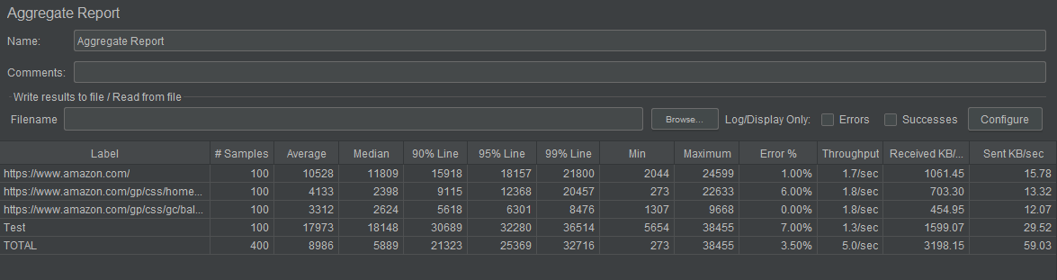

**Graph Results**

